APPLICATION TO ACCESS
ASIA PACIFIC PROJECT PREPARATION FACILITY (AP3F) RESOURCES

APPLICATION FORM FOR PROJECT PREPARATION SUPPORT

Part I – Project Details

- Applicant Details: (Name of organization, contact person and their contact details. Please also provide the Ministry of Finance / relevant Government contact person.)

Applicant: Ministry of Health, Labor and Social Affairs, 144, Tsereteli Avenue, Georgia

Mr. Valeri Kvarackhelia, Deputy Minister
Mr. Davit Chitaia, Department of Economy Chief Specialist ,
cell phone : 597 34 6234
dchitaia@moh.ge

- Proposed Project: (Describe the proposed project, its objective, perceived benefits and target beneficiaries. Please also include brief description of major components.)

Proposed project: Prefeasibility analysis to ascertain the potential of private sector participation in the rehabilitation, operations and management of a multifunctional hospital.

This is an application to assess pre-feasibility (PFS) for two similar proposed hospital projects.

Project 1 (Zugdidi Multifunctional University Hospital). This is a new Multifunctional hospital in Zugdidi and expected to be completed in September 2017. MOH is completing construction of the asset (expected July, 2017) is looking for private sector partner to equip, operate and manage this asset.

Project 2 (Kutaisi Multifunctional Hospital). MOH’s plan is to rehab this existing hospital, and is looking for a private partner to rehab, equip, operate and manage this asset.

Given the similarities of the two projects, this request includes information on both projects and the request is to get both the PFS’s done together and by the same consultant.

Objective: To improve public access to affordable health care in underserved communities.

Background: Project 1: Zugdidi Multifunctional Hospital

The Government of Georgia, as part of its initiative to improve health care in Samegrelo and surrounding areas, including the Autonomous Republic of Abkhazia is building a 220-bed multifunctional university hospital. The Ministry is considering tendering out for equipment, operations and management of the facility on a public-private partnership basis.
Location
The Ministry of Labor, Health and Social Affairs is developing a new multifunctional University hospital in the village of Rukhi, near Zugdidi, Western Georgia. Rukhi is at the northern edge of Zugdidi, the main city of the Samegrelo region. The hospital will primarily cover the Samegrelo population of approximately 100,000 and also serve patients from neighboring Abkhazia, Svaneti and Guria.

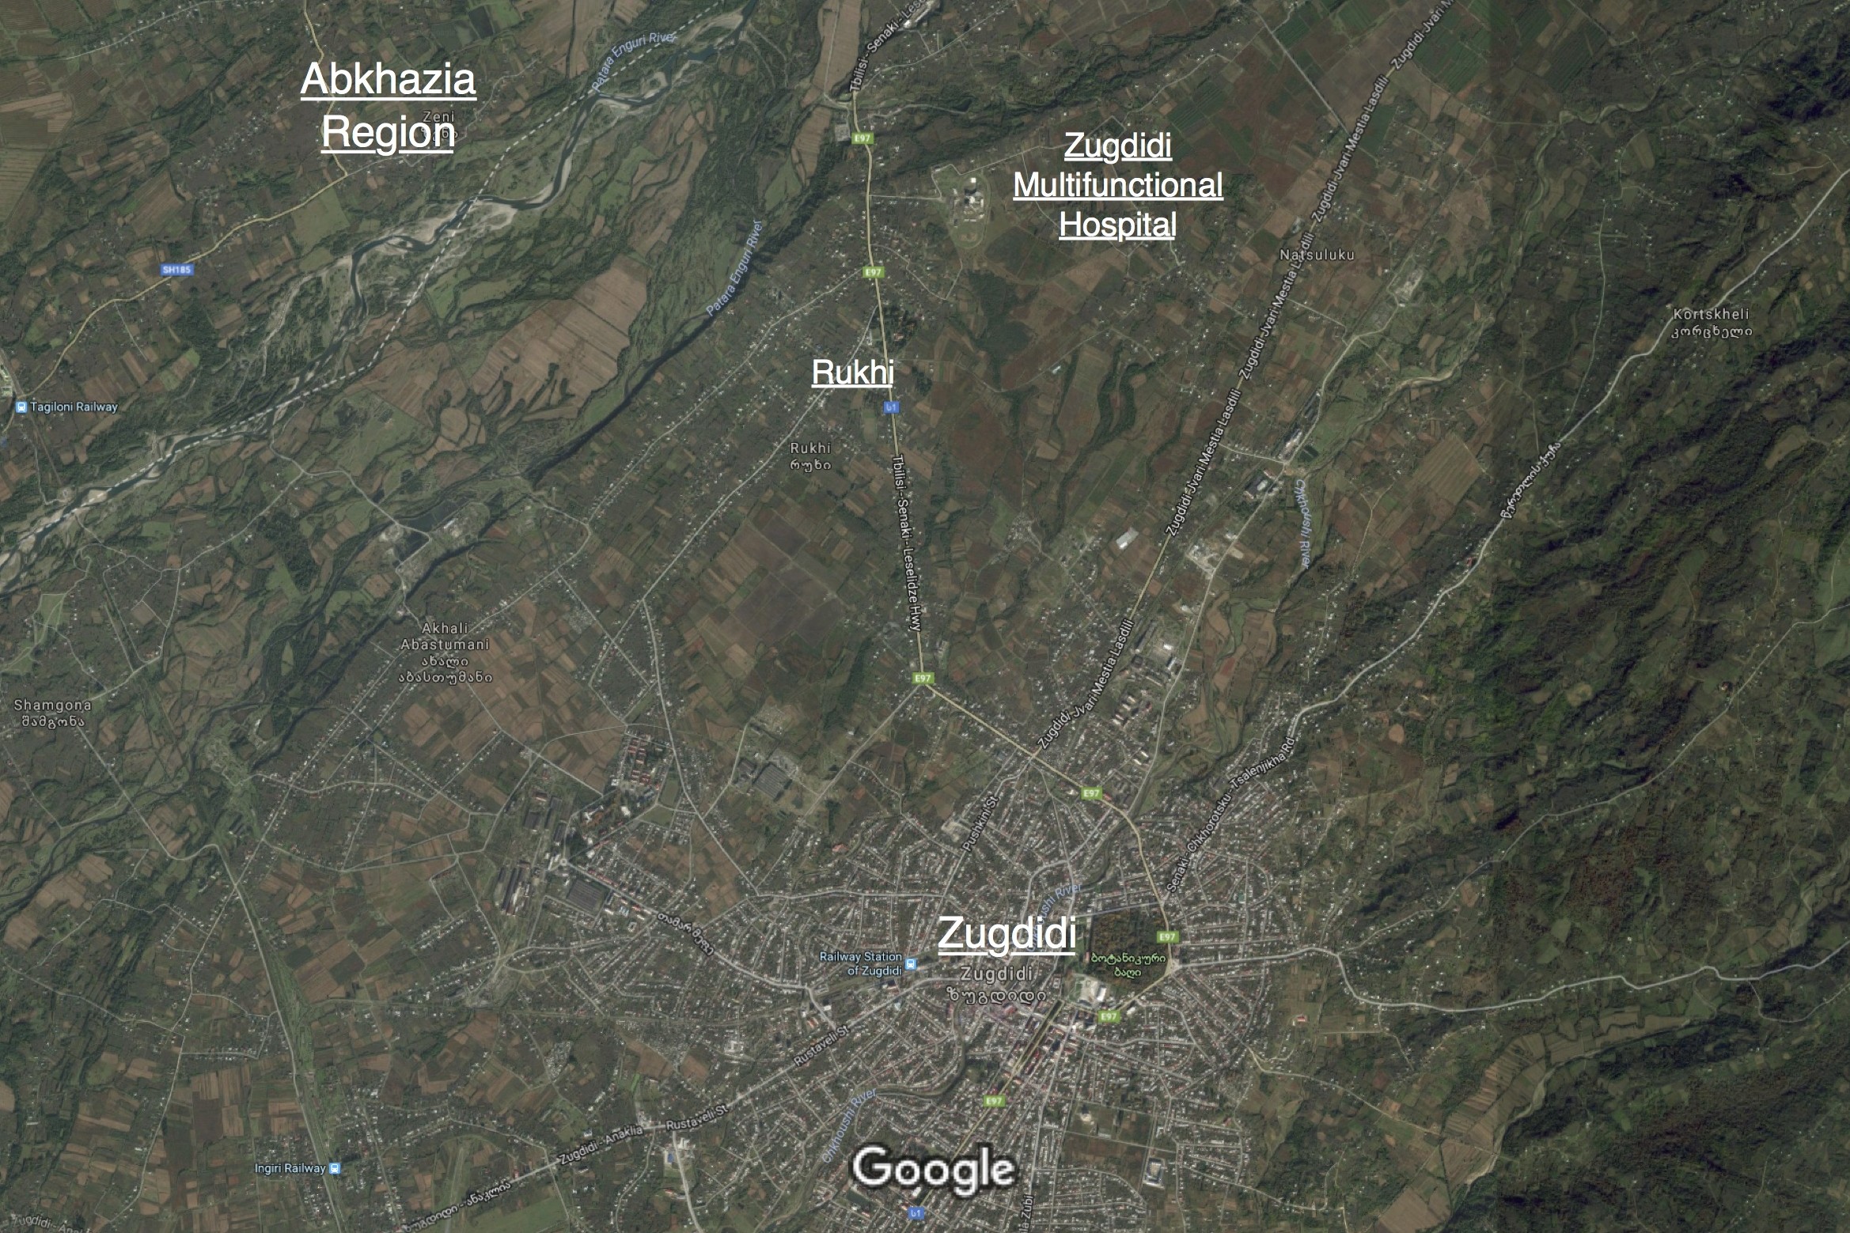
Figure 1: Proposed Location of Zugdidi Multifunctional University Hospital
The catchment area is also served by the St.Luka Zugdidi Medical Center, a private referral hospital run by the Georgia Healthcare Group.

Description of the project
The 25,000 square meter complex, which will include a 220-bed hospital, a university building, and a hotel, is being built on a 100,000 square meter site. The hospital is being built on land owned by the Ministry. After the conclusion of its construction in 2017, the hospital will provide multi-profile primary and secondary services with a wide range of outpatient and inpatient medical and surgical specialties, as well as 24-hour emergency services, all up to and including the secondary level. Classrooms and a library will also be built for students and residents on the hospital territory. Additional revenue generating facilities on the campus will include a sports facility, parking, and a hostel for residents, families and relatives of patients.

Background: Project 2: Kutaisi Multifunctional Hospital

The Government of Georgia, as part of its initiative to improve health care in Kutaisi and surrounding areas, is rehabilitating a 114-bed multifunctional university hospital. The Ministry is considering tendering out for equipment, operations and management of the facility on a public-private partnership basis.
Location
The Ministry of Labor, Health and Social Affairs is rehabilitating and upgrading an existing primary health care center in downtown Kutaisi to a multifunctional hospital. The hospital will primarily cover the Kutaisi population of approximately 200,000 (2013 census).
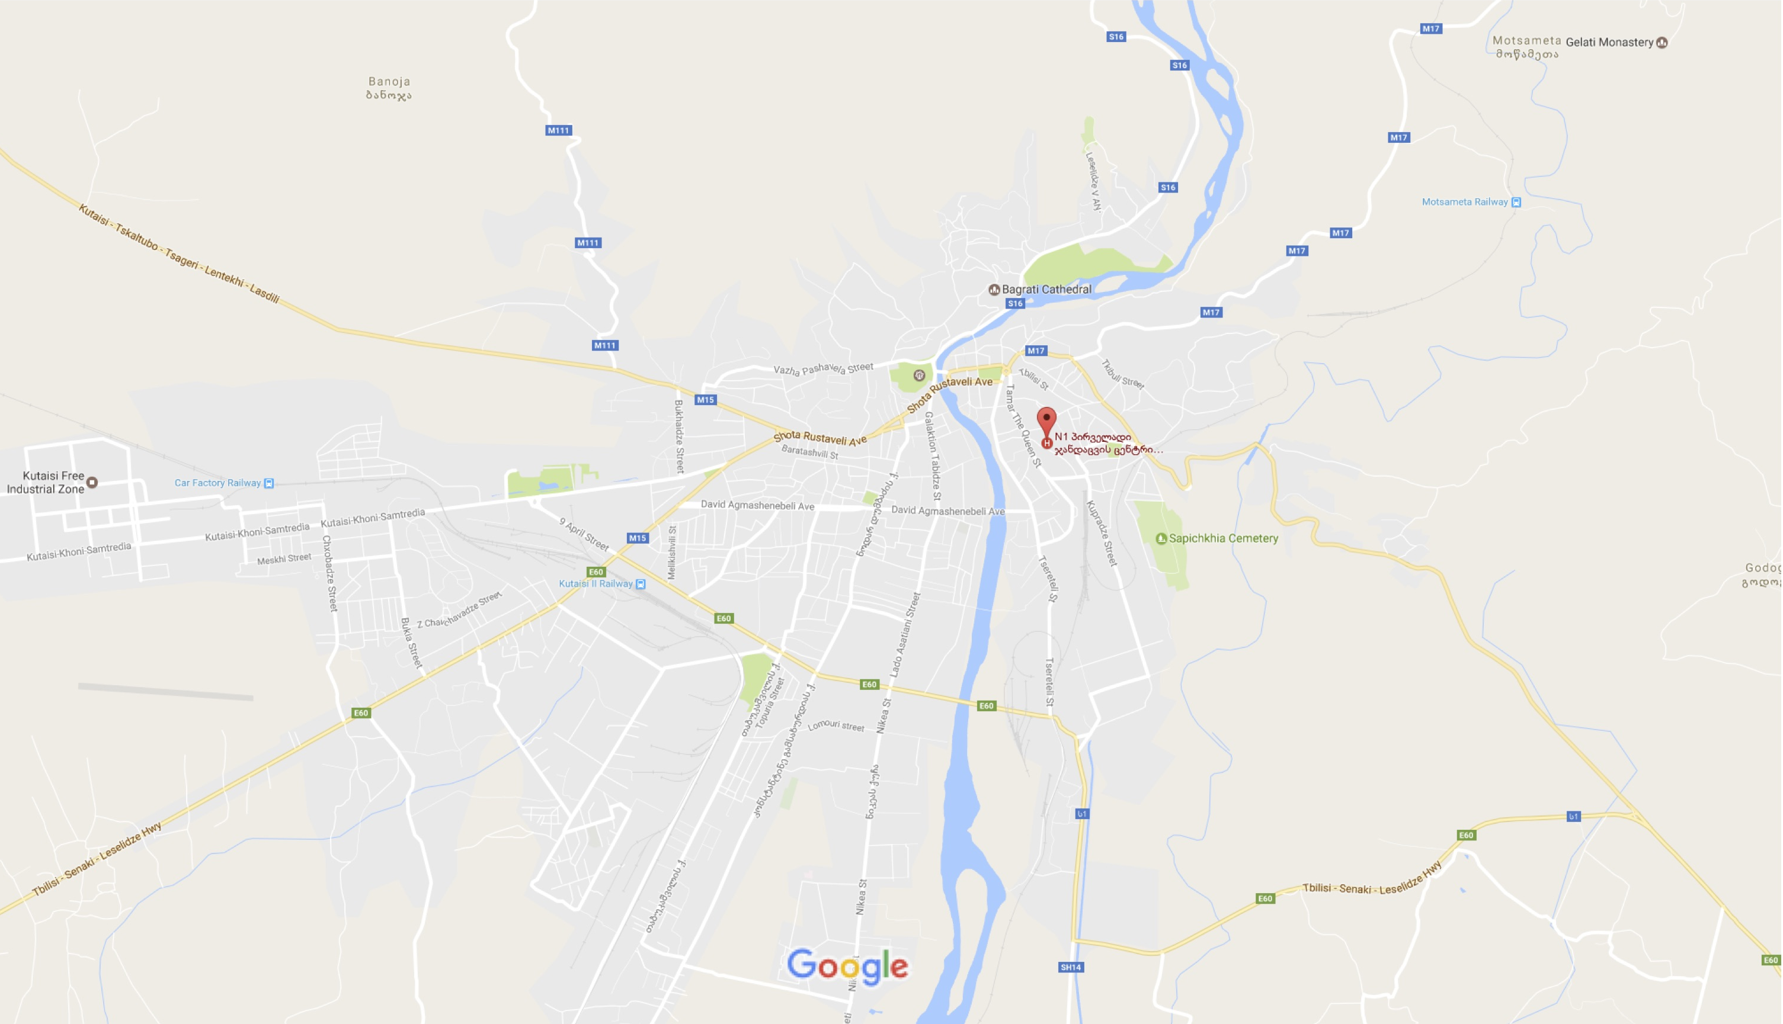
Figure 2: Location of Kutaisi Multifunctional Hospital in downtown Kutaisi
The catchment area is also served by the more than 12 other multi-profile clinics, 12 of which are bigger than the existing government owned Kutaisi Primary Health Care Center. Evex, a private healthcare firm in Georgia, owns three of these multi-profile clinics.
Description of the project
The 4,465 square meter primary health care clinic is situated on a 32,808 square meter plot with enough land for expansion. The land is owned by the Ministry. Proposed for rehabilitation in 2018, the hospital will provide multi-profile primary and secondary services with a wide range of outpatient and inpatient medical and surgical specialties, as well as 24-hour emergency services, all up to and including the secondary level.
Existing operations at the clinic cost approximately GEL 3,600,000. annually

Project(s) Justification

Industry and market overview
Healthcare services spending per capita is currently at a very low base of only US$217, with annual outpatient encounters of only 3.5 per capita and hospital bed utilisation of only 50%, all significantly lower than many comparable countries.

The Georgian healthcare industry has undergone a number of reforms and transformations during the last two decades. Favorable government policy has resulted in the privatization and renovation of nationwide healthcare infrastructure (of total nationwide hospital bed capacity, over 60% is new and only under 20% is in the public sector), including both ‘‘bricks and mortar’’ buildings and medical equipment, replacing rundown Soviet-era facilities.

Supportive government reforms and the engagement of private players in the sector have resulted in significant improvements in the overall standard of infrastructure and greatly boosted demand for quality healthcare services. The hospital market was GEL 1.2 billion in 2015 and this is forecasted to grow at a compound annual growth rate of 11.3% between 2014 and 2018.

Outlook and main growth drivers
According to forecasts by Frost & Sullivan, the hospitals segment is expected to grow at a compound annual growth rate of 11.3% from 2014 to 2018 to reach GEL 1.6 billion. The main growth drivers for healthcare services in Georgia are the following:

Improving infrastructure to support demand. Continued investment in healthcare infrastructure, mainly by private healthcare providers that are continuing to expand their businesses to address the growing demand for quality medical care from the population. This has included modernizing Soviet-era hospitals, upgrading medical technologies, facilitating easier access to healthcare and the addition of over 150 hospitals, with approximately 60% under private ownership.

Supportive government healthcare policies. Since its introduction in March 2013, the UHC has provided the entire population with access to quality healthcare and is expected to help increase demand for medical care, particularly hospital services. In addition, The Georgian government has been steadily increasing the budget that it allocates to healthcare, including to the UHC (described below) and specific, disease-oriented, vertical programmes.

Double digit growth in healthcare expenditure. Total healthcare expenditure in Georgia increased by almost seven times between 2000 and 2012. However, on a per capita basis, healthcare spending remains low compared to certain emerging market peers, pointing to further growth potential.

Rapidly growing healthcare services market. Historically high growth in the Georgian healthcare services market is expected to continue, supported by both the hospital and ambulatory clinic segments. Increasing health awareness and quality of services will lead to growth in demand for diagnostics. Between 2010 and 2013, the number of laboratory tests increased by 45%, from 5.5 million to 8 million.

Favourable demographics. The country has an ageing population, with an increasing proportion of its citizens aged over 60 who will require more frequent, better and prolonged healthcare treatments.

Funding options:

Funding options for the multi-functional hospitals need to be explored through the proposed PFS.

While the Georgian government is the main source of hospital service financing in the country, total government expenditure on health is very low at 2.7% of GDP, compared to the 5.0% benchmark set by peer countries, which leaves significant room for growth.

Universal Healthcare Program has provided basic healthcare coverage to the entire population since 2013. According to the IMF, this reform should improve healthcare outcomes and is estimated to add 1% of GDP per year to existing healthcare costs, making healthcare the largest area of reform in the country. Healthcare service providers (both state and private) generate revenue from out-of pocket payments (including fee-for-service and universal healthcare co-payments), transfers from state healthcare programs and payments from private medical insurance companies. Medical insurance companies depend on revenues from medical insurance policies purchased by employers for their employees and by individuals for their own use.

In March 2013, the UHC was introduced to address high private healthcare costs in Georgia. The UHC is a government-funded healthcare program that provides basic healthcare coverage to the entire population, including more than two million people who had never held medical insurance and purchased healthcare services only on an out-of-pocket basis. Unlike the preceding SIPs, the UHC is not an insurance product but an undertaking by the government to reimburse healthcare providers directly for the delivery of treatment to patients. The program is subject to certain limits and service and coverage exclusions, beyond which patients have to fund treatment on an out-of-pocket basis or rely on private medical insurance coverage. The key principles of the UHC program are as follows.
- The UHC covers basic outpatient elective services most emergency care services, and elective inpatient services, subject to certain limits.
- The UHC is fully financed by the government from tax revenues and administered by the Social Service Agency (SSA)—a body under the Georgian Ministry of Labour, Health and Social Affairs). In most cases, beneficiaries have an annual limit of GEL 15,000 for planned procedures. For emergency admissions, the limit is GEL 15,000 per incident for all individuals, except those from certain socially vulnerable groups and children under six. For planned procedures, patients are required to obtain approval from the SSA prior to treatment. These thresholds limit the services that a patient can access and result in the need for co-payments by patients for elective services and certain emergency services. There is a maximum two-month waiting time to obtain approval for elective inpatient services.
- UHC beneficiaries are entitled to select any healthcare provider of their choice provided it is enrolled in the program as a provider of the requested service.
- Any provider, whether private or state, is eligible to participate in the program. The actual prices that are charged to patients by healthcare providers are not regulated by the state. However, the reimbursement paid by the SSA to the healthcare providers under the UHC differs depending on the type of service provided and the location of the facility (in some cases reimbursement rates are higher in Tbilisi than in the regions).

Financial viability:

The financial viability of the project, as discussed in the Project Preparation Assistance section below, is to be explored through the proposed PFS.

Legal issues: No legal issues are foreseen in the development of the projects.

- Scope of Project Preparation Assistance Required: (Describe the project development activities and timelines starting from the appointment of consultants and advisors culminating in the selection of the private sector partner.)

The MOHLSA is requesting assistance to develop the pre-feasibility analysis for the two multifunctional hospitals to assist them in assessing the potential for private sector participation in the rendering the services of the hospital.

The PPP prefeasibility for the hospitals should focus on four aspects:
- Based on a market and demand analysis, what facilities should the Zugdidi Multifunctional University Hospital and Kutaisi Hospital have?
This market analysis should answer questions relating to:
- Demographics
- Population served
- Prior inflow and outflow
- Services required at the hospital
- Equipment needed at the hospital
- Workforce needed at the hospital, and finally
- Demonstrate ability to compete with other hospitals in the catchment area.

Note that for Zugdidi Hospital, MoH has already answered the above questions – and given specifications to the architect who has designed the building accordingly.

This section should also discuss how the project will enhance social, environmental, and gender aspects in its area of influence.

- Should the equipment, operations and management for these facilities be provided by MOH or should we get the private sector to provide the O&M for the hospital?
The Information to collect should include:
- Final version of excel worksheet from architect – showing facilities
- Expected patient inflow for different services – inpatient and outpatient
- Demand Analysis to identify services envisaged for the hospital.
  - List of services
    - Beds/service
    - Equipment per service
  - Project Capital Cost:
    - Building (including rehabilitation)
    - Equipment
  - Manpower needed:
    - Doctors, nurses, general staff, etc.
    - Salary Costs
  - Project Operations and Maintenance Cost:
    - laundry,
    - building maintenance
    - Facility management

- The PFS should include a market landscape assessment and market sounding to assess if there are providers with the capability and interest to meet MOH’s procurement and affordability requirements.

- A financial feasibility analysis, based on market sounding, should include an options analysis, analysis of affordability, value-for-money and recommendations for a preferred procurement method. The financial model (in MS Excel) should discuss capital costs and operating revenue and expense structure.
- Cost factors
- Revenue/bed and expense/bed
- Expense/bed and expense/service
- Payment structure from users
- Potential of government annuity, if needed

- Estimated Funding Requirements for Project Preparation: (Indicate the estimated budget linked to project milestones)

Estimated preparation costs (approximately):
- Pre-Feasibility Study 60,000-100,000 USD

- Scope of Private Sector Involvement: (Describe how the private sector may be involved during project implementation, operation and/or maintenance. The perceived arrangement including cost recovery mechanisms should be indicated)

Zugdidi Multifunctional Hospital
- Equipping the hospital, estimated to cost $30-$40 million.
- Financing equipment for the hospital
- Maintenance and operations of the hospital
- Transfer of the hospital to the government at end of concession period.

Kutaisi Multifunctional Hospital
- Rehabilitating the existing facility, estimate cost:
- Equipping the hospital, estimated cost::
- Financing equipment for the hospital
- Maintenance and operations of the hospital
- Transfer of the hospital to the government at end of concession period.

- Legal and Regulatory Framework:(Describe the provisions under the relevant Acts/Rules that grant authority to the Public Sponsor for developing and implementing the project and the proposed decision-making steps to award the project)

The Government of Georgia is currently developing its legal and regulatory framework for PPPs. The institutional framework to facilitiate decision-making is being developed.

- Addressing social, environmental, and gender concerns: (Describe how the project will enhance social, environmental, and gender aspects of the project, or mitigate social, environmental, and gender concerns associated with the project.)

To be discussed through the Project Preparation Assistance request.

- Overview of Counterpart Funding for Project Preparation: (Describe what contributions your agency would commit, in cash and in kind, the others sources of funding that will be mobilized and the total estimated contribution towards the estimated project preparation cost outlined in Item 4. Include information on previous applications with other project preparation facilities)

<< David, can MOH can provide any funding (nominal or in-kind – staff, space to work, transport, anything) to help the consultants).

- Priorities: (AP3F support for the preparation of infrastructure projects will be prioritized where such projects demonstrate strong qualities in the following categories. Please tick where appropriate and provide the requested descriptions where applicable).

Priorities | Remarks
Priorities | Yes | No | Explanation / Description
Climate resilience (Describe how the project will take into account climate change into its design. Please use ADB’s Checklist for Preliminary Climate Risk Screening or equivalent) | + |  | The rehabilitation of the Kutaisi Hospital will increase climate resiliency.
Sustainability and impact on poverty reduction (Describe how the project will be sustainable. Also describe the poverty reduction initiatives under the project.) | + |  | - Sustainability:  - Although a demand analysis yet to be done, the Ministry’s opinion is there exists significant demand for affordable service in these markets.  - PFS will review the market, the demand and the supply – to identify potential private sector partners that meet the affordability criteria that MOH is targeting. The PFS will analyze sustainability of the project by looking at key components of : 1. Potential pricing of facilities, 2. Affordability of the market; and 3. Annuity payments beyond UHC, if needed.  - tolling and government annuity payments.  - Poverty reduction:  - The country has an ageing population, with an increasing proportion of its citizens aged over 60 who will require more frequent, better and prolonged healthcare treatments. Healthcare has therefore taken on an increasing role in reducing livelihood risk.
Enhancement of regional connectivity and/or support for greater regional economic integration (Describe how the project will enhance regional connectivity.) | + |  | The Zugdidi Multifunctional hospital will serve an underserved part of the country.  Both the Zugdidi and Kutaisi hospitals will be focused on providing affordable healthcare services to people in lower and middle segments of the economy.
Prioritization by respective DMC Agency or by association with sectors identified in the DMC’s country partnership strategy with ADB (Cite the document or list in which the project was identified as a priority) | +
Noteworthy innovation (Describe if/how the project is a “pathfinder” project or first of its kind in a sector or DMC) | + |  | - The project will be the first PPP project to be developed as part of an ongoing TA on legal and institutional framework and capacity development.
New investment or enhancement of existing project | + |  | - Enhancement of existing investments

APPLICATION FORM FOR CAPACITY-RELATED ASSISTANCE
NOT APPLICABLE

- Type of assistance requested: (Please tick the type of assistance requested)

- Applicant Details: (Name of organization, contact person and their contact details. Please also provide the Ministry of Finance / relevant Government contact person.)

- Proposed Activity: (Describe the proposed activity, its objective, perceived benefits and target beneficiaries. Please also include brief description of major components.)

- Development of tolling policy for the Kyrgyz Republic.
- Capacity building of Ministry of Transport and Communications:
  - Establishing PPP node
  - On-the-job training by international and national experts
  - PPP training.

- Estimated Funding Requirements Needed for Capacity Assistance: (Indicate the estimated budget linked to activity milestones)

- Timetable for Design and Implementation: (Describe the activities and timelines)

- Related Assistance Provided: (List down all past and ongoing assistance provided by other agencies in relation to the activity being proposed, if any.)

- Relation to Projects: (Describe any links and relevance to specific projects)

Frost and Sullivan, Healthcare Services Market Outlook for Balkan and CIS, Country-level Analysis of Healthcare Systems and Private Hospital Markets, 2015

